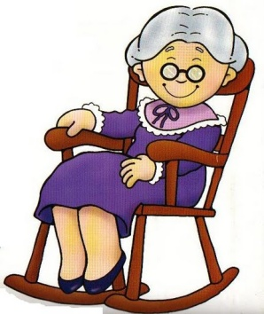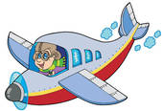

Complete with the missing compound noun from the box at the bottom

**4.**Lucy is a ____________.

**1.**My ___________ is very

heavy.

**3.**__________ is sitting on arocking chair.

**2.**This pilot flies an old____

___________.

.

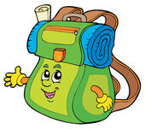



**8.**Mr. Smith is a________.

**7.**Peter isa ____________.

**6.**James plays ___________

at school.

**5.**The _________ is very

colourful.

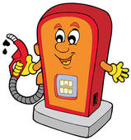

**12.**My new house is near the___________.

.

**9.**Peter’s _____________ are very happy.

**10.**There is a mug on the

________________.

**11.**Susan has lost her _____

_________.



**16.**Lucy’s ______________

Is always full of love letters.

**15.**Mrs. White is a very good ______________.

.

**14.**I love my mother’s

______________.

**13.**The ___________is used in the construction business.

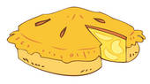

|  |  |  |  |  |  |  |  |
| --- | --- | --- | --- | --- | --- | --- | --- |
| **schoolmates** | **businessman** | **firefighter** | **Grandmother** | **Petrolstation** | **bulldozer** | **Mailbox** | **housekeeper** |
| **Cheerleader** | **basketball** | **airplane** | **bedside table** | **cell phone** | **butterfly** | **apple pie** | **backpack** |