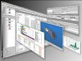

**database**

**programme**

**computer**

**browsers**

**spam**

**monitor**

**download**

**short cut**

**database search**

**cursor**

**icon**

**laptop**

**keyboard**

**software**

**link**

**external hard disc**



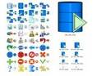







KEYBOARD

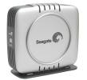

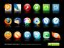

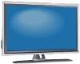

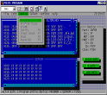

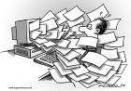

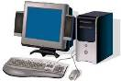



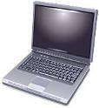

link