 |  |  | 
- Parvati (read) .....................  .................................................  the book all afternoon. | - They (telephone)  ............................................... for hours. | - Jenny, how many apples  you (pick) ...............................? | - He is very tired now. He (run) ............................
 | 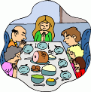 |  | 
- Molly (study) ..........................  ............................ hard. She’ll take an exam next week. | - Dinner’s ready. My mother (cook) .................................a good meal for the family. | - What you (do) .....................  ...................................., Sirius?  You are covered in paint. | - They (run) ....................  .........................................  4,000 meters.
 |  |  | 
- How long Peter (wait) .......  ..................................................  for the bus? | - My grandparents (live) ...............................................  in this house all their life. | - My grandpa (visit) ...............  ................................................  many different countries. | - They (decorate) .........  .................................... the house for Christmas. It looks nice.
 |  |  | 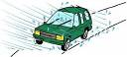
- These boys (fight)  ....................................... for 15 minutes. They (have)  ................................................. 3 fights this week. | - They (just/arrive) ...........  .................. home from Spain. They look sunburned. I think they (lie) ................................................ in the sun. | - He (not/do) .............................anything to help his wife this evening because he (watch) ................................. TV for the last 2 hours. | - Kate has to stay at home because it (rain) ..............  .................................................  heavily for hours.
 |  | 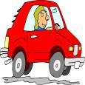 | 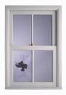
- He (cough) ..............................  ............. a lot recently. He should give up smoking. | - I can smell something sweet. You (cook) ..........  .................................., dear? | - He (drive) .............................  ...............................397 miles, from London to Aberdeen. | - Someone (break) ...............  ...............................................  the window.

