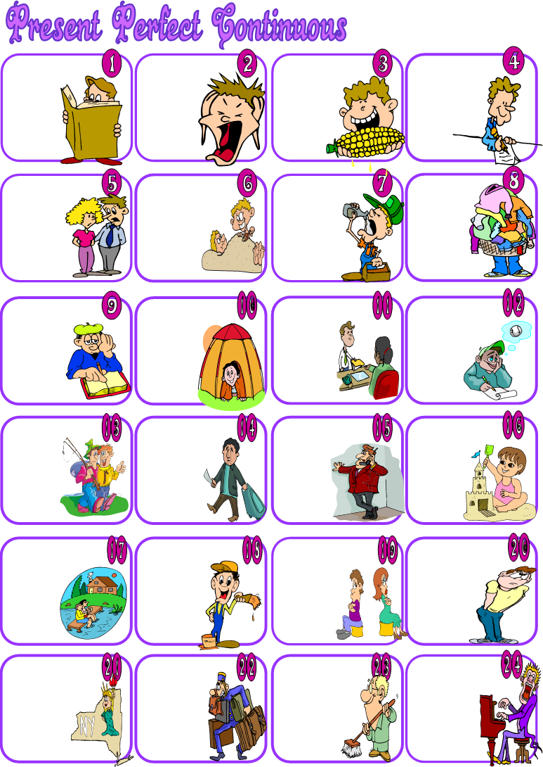

I ________

(read)

this book.

We ________

(shout)

all the time.

_________(eat)

all the

food?

He _______

(not/ write) a

message.

_______ (he/ speak)

English?

They _______(go) to the beach.

You _______

(drink) a lot.

They ______

(buy) cheap

clothes.

I ________(study)

for the

exams.

______(he / sleep)

in the

tent?

She ________

(work) in a

bank.

He ________(do)

his homework..

They _______

(help) their

friends.

He ________

(travel) all

year.

I _____________

(telephone)

you all

morning.

_______(she/sit)

on the sand

all the

time?

We _______(not/ live) here all

the time.

________(you/ paint) for

the last two

hours.

________ (they/ sit) all the

time?

I ______(not/ wait) for you.

________(they/not/live) in

New York?

_______(he/ not/ stay) in the hotel?

__________

(you / not / clean) the room?

__________

(he / not / sing)?

Fill in the blanks with the **Present Perfect Continuous** of the verbs in brackets.