**Student’s name**: __________________________________.

WORKSHOP 5 – Present Continuous and Verb to be.

Instructions:

1. Upload your workshop on [www.emmanuel.cl](http://www.emmanuel.cl) – Plan Preventivo – 7°básico - Buzón de tareas 5.
2. Due date: November 19th.
3. Teacher’s email: [vc.acevedocontreras@gmail.com](mailto:vc.acevedocontreras@gmail.com) (Valentina Acevedo) in case of any doubt. (Please indicate your name in the mail).
4. Complete the following *affirmative sentences* with the **Present Continuous**.
5. You _________ (wear) my new T-shirt! Take it out.
6. My dad _________ (wash) the car.
7. It __________ (rain) in the south of Chile right now.
8. My classmates ________ (do) the workshop now
9. They __________ (dancing) in the living room.
10. Javiera and I _______ (study) for the History test.
11. I ________ (finish) the semester! I want vacations.
12. Complete the following *negative and interrogative sentences* with the **Present Continuous**.
13. Today it _________ (not rain) in Santiago.
14. Harry Styles ________ (not come) to Chile ☹
15. I ________ (not wear) pajamas right now.
16. What _________ (you/do) at the moment?
17. ______ we _______ (go) to the beach this weekend?
18. When _____ he ______ (come) to our house?
19. **What are the people doing?** Describe what the people are doing in the pictures.

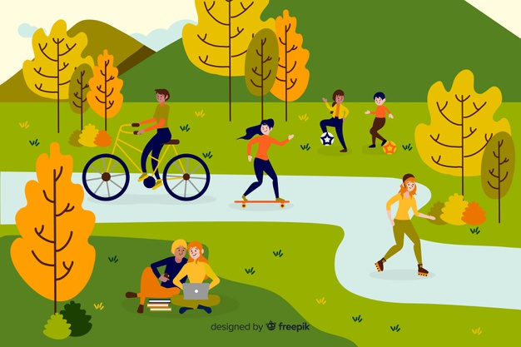

1. She____________ (ride) a bicycle.

2. _______________ (study) together

3. _______________ (practice) skateboarding.

4. ________________ (play) football.

5. ______________ (practice) rollerblading.

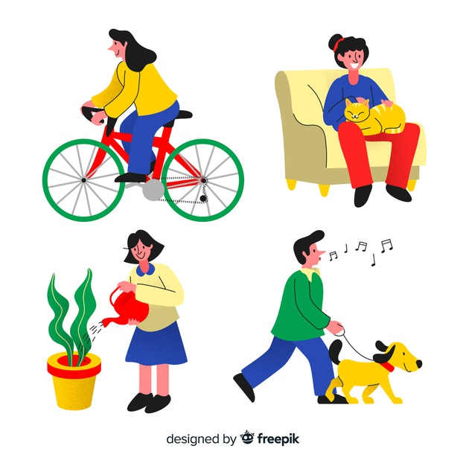

6. _____________ (water) her plants.

7. ______________(walk) the dog.

8. _____________(touch) the cat.

1. Identify what is **the situation** of the sentences.

Could be:

1. Something happening at the moment
2. Temporary situation
3. Future plans/arrangements.

|  |  |
| --- | --- |
| 1. Julie is sleeping now. | **A** |
| 1. We’re having a test tomorrow. |  |
| 1. She’s staying here for a week. |  |
| 1. I’m eating a lot these days. |  |
| 1. Right now I’m doing the English workshop |  |
| 1. Lucy is wearing a dress at the moment |  |
| 1. I’m meeting my friend tomorrow. |  |