**Student’s name**: _______________________________________.

WORKSHOP 4

Instructions:

1. Upload your workshop on [www.emmanuel.cl](http://www.emmanuel.cl) – Plan Preventivo – 7°básico - Buzón de tareas 4.
2. Due date: November 12th.
3. Teacher’s email: [vc.acevedocontreras@gmail.com](mailto:vc.acevedocontreras@gmail.com) (Valentina Acevedo) in case of any doubt. (Please indicate your name in the mail).

Present Continuous.

1. Read the examples of the **present continuous** in the box below. Choose the correct option from the sentences that follow.

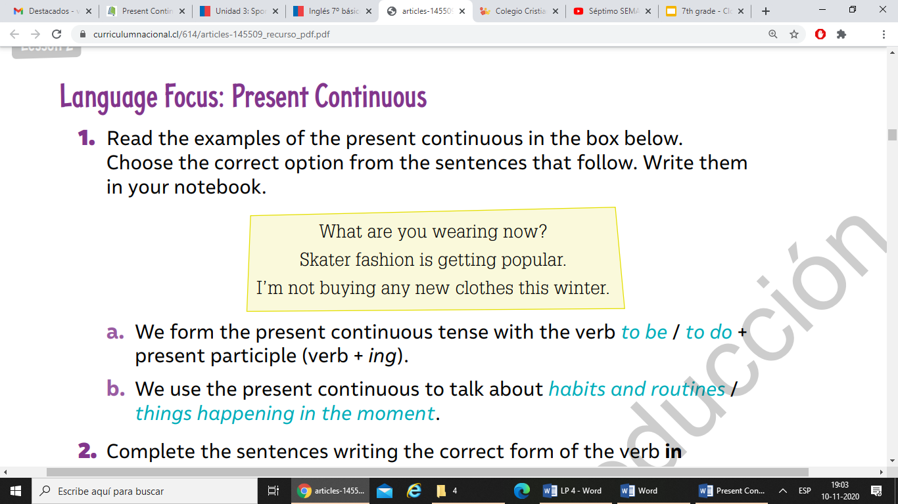

Highlight the correct answer.

a) We form the **present continuous tense** with the verb to be / to do + present participle (verb + ing).

b. We use the **present continuous** to talk about habits and routines / things happening in the moment.

1. Complete the sentences writing the correct form of the verb.

Tom and Sara like sports. This year, they **________** (play) basketball for the school team. Tom **_________** (wear) a red shirt to practice in. Sara **___________** (not wear) red because in this practice she **_______** (play) for the other team. "At the moment, we **___________** (practice) for a tournament that starts next week," says Tom.

1. Look at the picture and write five sentences describing what the people are doing and/or wearing.



Example:

They are watching television.

1. .
2. .
3. .
4. .
5. .