**Student’s name**: _______________________________________.

Instructions:

1. Upload your workshop on [www.emmanuel.cl](http://www.emmanuel.cl) – Plan Preventivo – 7°básico - Buzón de tareas 3.
2. Due date: November 5th.
3. Teacher’s email: [vc.acevedocontreras@gmail.com](mailto:vc.acevedocontreras@gmail.com) (Valentina Acevedo) in case of any doubt.
4. Match the part of the body with the item of clothing.

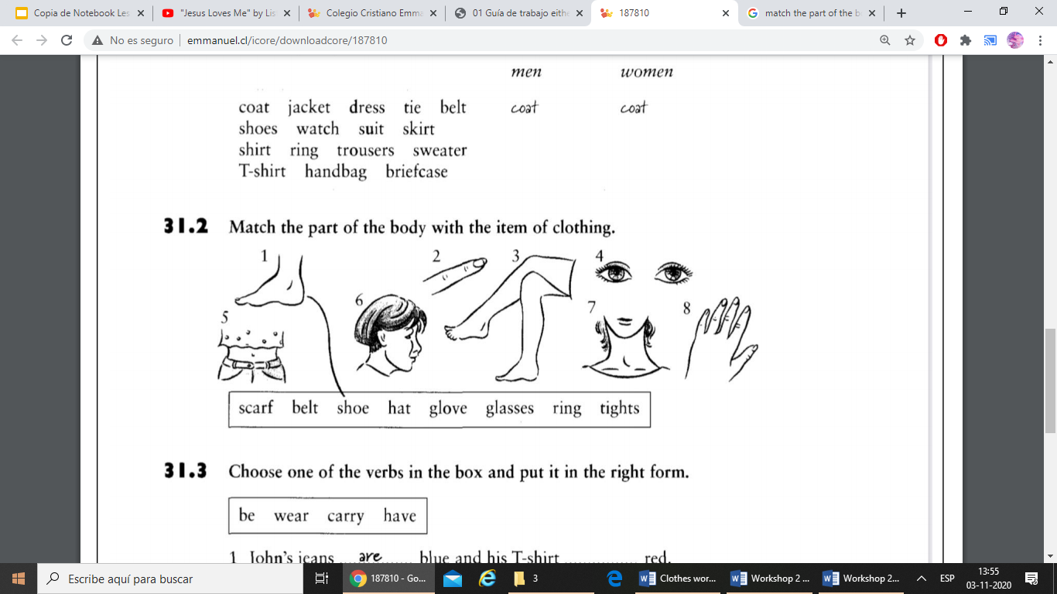

|  |  |
| --- | --- |
| 1. **Shoe** |  |
|  |  |
|  |  |
|  |  |

1. Look at the pictures and write the names of the clothes next to the numbers. Choose the words in the box. You can repeat the words if necessary.

|  |
| --- |
| T-shirt Shirt Coat Suit Belt Sneakers Shoes Briefcase Trousers Hat Sunglasses Ring Scarf Watch Socks Dress Jacket |

**3)**

**4)**

**5)**

**6)**

**2) Belt**

**1) Shirt**

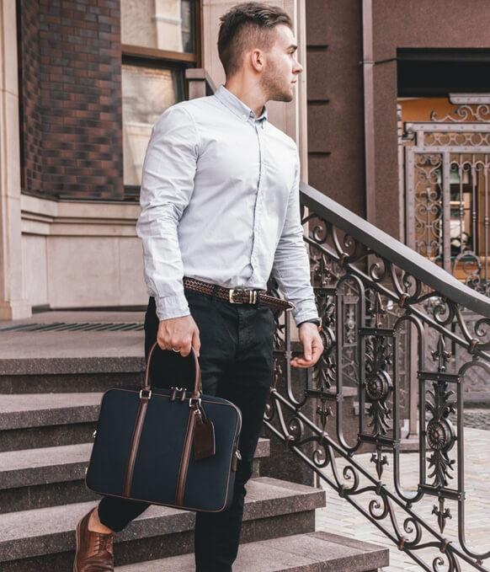

**2)**

**1)**

**3)**

**4)**

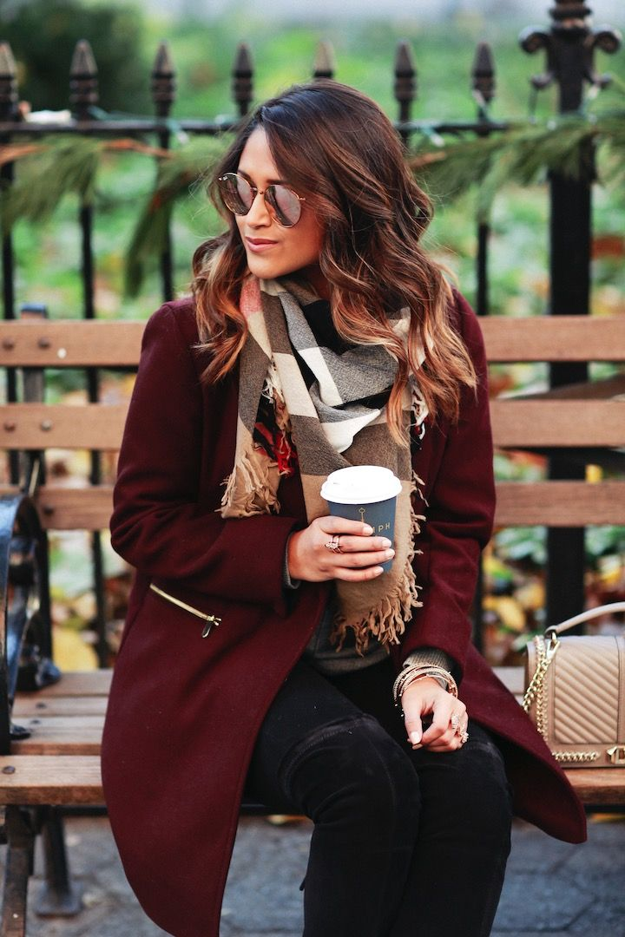

1. 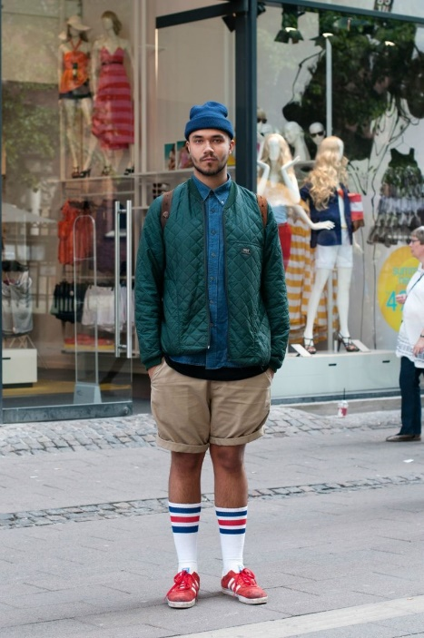

**6)**

**5)**

**4)**

**3)**

**2)**

**1)**

**2)**

**3)**

**4)**

**1)**

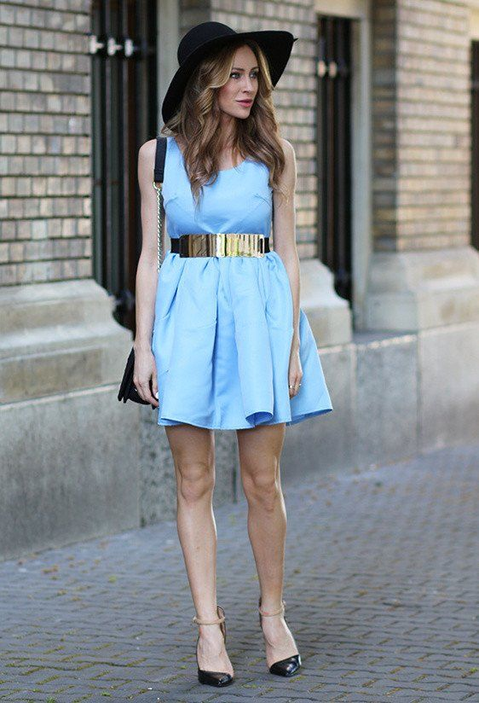

1. Write a paragraph about what you are wearing today.

Ex: Today I’m wearing a black T-shirt and a green sweater. I’ve got a pair of blue jeans on. I’m wearing white socks and white sneakers. I have also a ring and a pair of glasses on.

* _________________________________________________________________________________________________________________________________________________________________.