Grammar:
expressing ability
CAN / CAN'T:

A. Look at the pictures and write sentences about what these people CAN or CAN’T do.
Use these verbs:

☺ dance ☺ swim ☹ sing ☹ cook ☹ drive
☹ run ☹ ski ☺ play the piano ☹ ride a horse ☹ paint

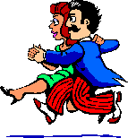      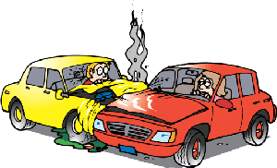      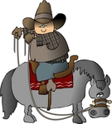        1. | 2. | 3. | 4. | 5.
6. | 7. | 8. | 9. | 10.

1. Sarah and Tom_______________________ 2. Mary ____________________________________
3. Tony _______________________________ 4. That man ________________________________
5. Granny _____________________________ 6. She _________________________ the marathon.
7. They _______________________________ 8. Tina ____________________________________
9. He _________________________________ 10. Mr Smith _______________________________

B. And you? Can you do these things?
Write short answers.

1. Can you speak French? ___________________________________
2. Can you ride a bike? ___________________________________
3. Can you play chess? ___________________________________

4. Can you bake a cake? ___________________________________
5. Can you whistle? ___________________________________
6. Can you dive? ___________________________________

C. What can you do? What can’t you do? Write 3 answers for each question.
______________________________________________________________________________________________________________________________________________________________________________

D. Look at the pictures and complete the sentences with can/can’t and a verb.

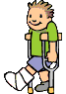  1 |   2 |   3 |   4
  5 |   6 |   7 | 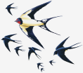  8

1 He ________________________ 5 They ____________________
2 It _______________________ 6 She ______________________
3 She ______________________ 7 He ______________________
4 He _______________________ 8 They ____________________

E. Answer:

Can a bird sing?_________________________________________________________
Can a snake jump?_______________________________________________________
Can a horse run?_________________________________________________________
Can a fish swim?_________________________________________________________
Can an elephant fly?______________________________________________________

F. Form questions and answer them:

MOTHER / YOUR / CAN / DRAW
______________________________________________?
______________________________________________

CAN / GRANDPARENTS / GUITAR / PLAY /THE / YOUR
______________________________________________?
______________________________________________

